Transformations Pre-Test Name_________________________________

- Reflect across the line y = 2x – 1. 2. Find the point of rotation:

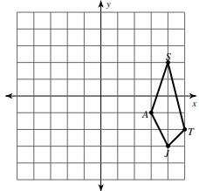

3. Rotate 90° about (-1, -1)

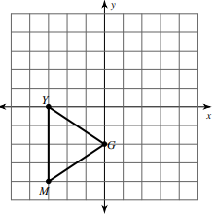

Find the degree of rotation for the two shapes:

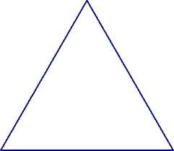

7. ________________ 8. _________________

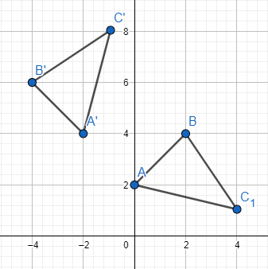

4. Find the number of diagonals for

5. How many lines of symmetry? ____

6. Construct the line of reflection below:

9. Bisect the angle:

10. Construct a perpendicular bisector. 11. Construct a perpendicular line through the point.

